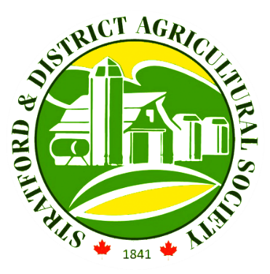

Stratford Fall Fair Sponsorship

The Stratford & District Agricultural Society (SDAS) is once again thrilled to be hosting our annual Stratford Fall Fair from September 22 – 25, 2022 where we strive to connect rural and urban communities. Each year the SDAS looks to partner with community businesses like yours to fill each day with events and attractions while promoting local businesses. To aid in the success of our annual fall fair, we humbly ask for your support. If you wish to financially support a specific event at our fair, please make note of that so we may allocate your donation in the correct location.

Below is a list of sponsorship levels and the sponsorship recognition that goes along with each level.

RED RIBBON– sponsorships of $5,000
*solo sponsor of specific event at the fair
*announcement of your company name during the fair
*signage with your company name displayed at the fair
*advertised as a Red Ribbon Sponsor on our social media

BLUE RIBBON – sponsorships of $2,500
*announcement of your company name during the fair
*signage with your company name displayed at the fair
*advertised as a Blue Ribbon sponsor on our social media

WHITE RIBBON – sponsorships of $1,000
*signage with your company name displayed at the fair
*advertised as a White Ribbon sponsor on our social media

YELLOW RIBBON – sponsorships of $500
*signage with your company name displayed at the fair
*advertised as a Yellow Ribbon Sponsor on our social media

FAIR FANS – sponsorships of $100
*advertised as a Fair Fan on our social media

If your company or organization is interested in partnering with the SDAS please contact our office administrator, admin@stratfordfairgrounds.com or call 519-271-5130 for more details.

